FOR IMMEDIATE RELEASE May 8, 2019

2019 TOYOTA SIENNA IS HOLE-IN-ONE AT HANMI TOURNAMENT

SAIPAN, NORTHERN MARIANA ISLANDS – A 2019 Toyota Sienna from Atkins Kroll Saipan awaits one lucky hole-in-one winner at the 18th Annual HANMI Charity Classic Golf Tournament on May 11, 2019, at LaoLao Bay Golf & Resort West Course.

“Atkins Kroll Saipan is proud to continue supporting HANMI and their annual charity golf tournament, and we are pleased to offer our brand new 2019 Toyota Sienna as a hole in one prize,” said Clark Boswell, General Manager of Atkins Kroll Saipan. “HANMI is a wonderful organization that supports and drives the leading industry of tourism in the CNMI, and we’re looking forward to another successful event this coming weekend.”

The tournament follows a black-jack double Peoria format and is offering more than $100,000 in cash, cars, hotel night stays and other prizes for players.

“On behalf of Hotel Association of the Northern Mariana Islands and the charitable organizations that will benefit from our tournament in the year ahead, we want to thank AK Saipan and all our generous sponsors and players this year,” said Tournament Chairman Steve Balakrishna. “It’s absolutely amazing to have sold out the tournament just a few days after our early bird deadline, and we certainly hope to see some lucky player drive away from hole #3 with this spacious Toyota Sienna, or any of our other great hole-in-ones.”
Additional hole-in-one prizes include $20,000 from Century Tours, $20,00 from LT Travel, a 2019 Mitsubishi Eclipse Cross from Triple J Motors, and $5,000 from Pacifica Insurance, a first-class roundtrip ticket from Saipan to Shanghai or Guangzhou on Sichuan Airlines from Saipan Travel Inc., and $2,500 from Traders Insurance.
For an additional $30.00, players may also compete for optional play prizes, including Accurate Drive on Line (#9), Accurate Drive Circle (#5), Aggressive Drive (#12), Longest Drive (#18), and Nearest to the Pin (#3, #7, #13, #17). The tournament will start at 7 a.m, and the awards banquet will be held the same day at 6 p.m. at Grandvrio Resort Saipan.

For more information, contact Tournament Chairman Steve Balakrishna at steve.balakrishna@picsaipan.com or 1.670.234.7976 or visit www.facebook.com/HANMI670.

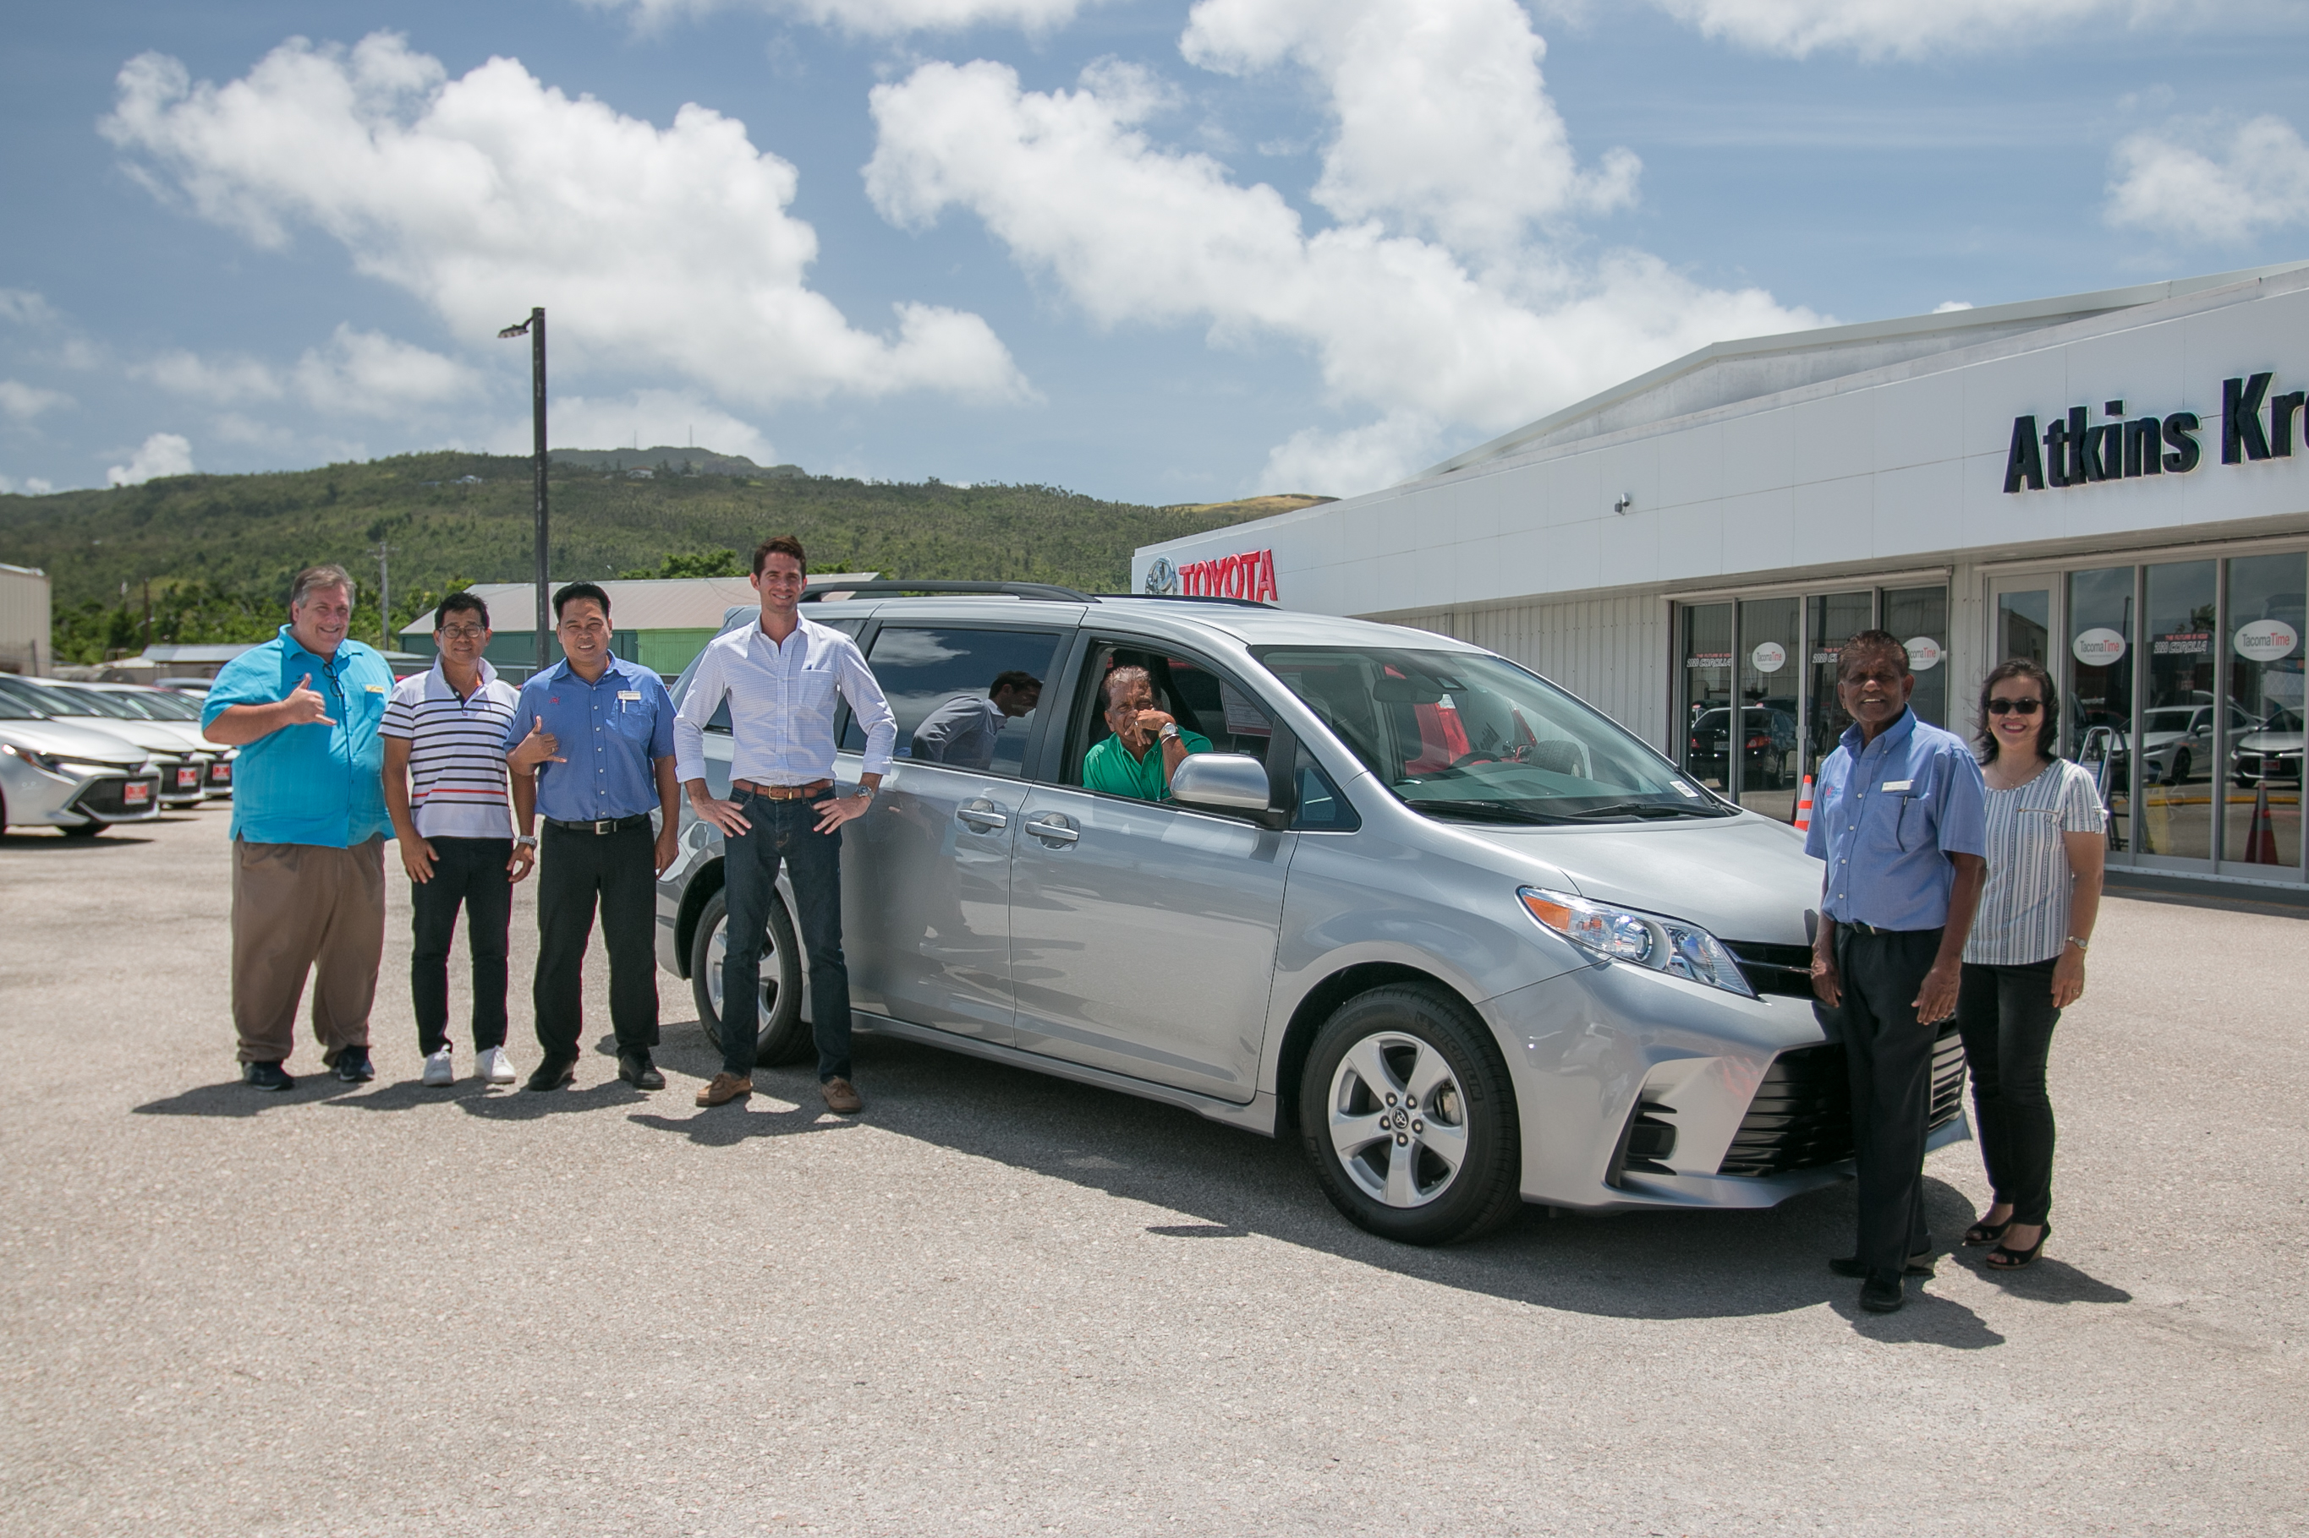
Atkins Kroll Saipan General Manager Clark Boswell, fourth from left, donates a 2019 Toyota Sienna as a hole-in-one prize on May 3, 2019, for the 18th Annual HANMI Charity Classic Golf Tournament on May 11, 2019. From left, Tournament Committee Members Glenn Policare, Steve Jang, and Rommel Bartolo; Boswell; Tournament Committee Member Das Krishnan; Tournament Committee Chairman Steve Balakrishna, and Tournament Committee Member Socorro Huliganga.
###
For More Information:
Catherine Perry
670.288.8433

