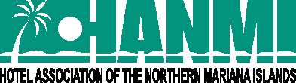

FOR IMMEDIATE RELEASE June 15, 2021

HANMI CHARITY CLASSIC GOLF TOURNAMENT ON AUG. 14, 2021

SAIPAN, NORTHERN MARIANA ISLANDS – The 19th Annual HANMI Charity Classic Golf Tournament will be held on Aug. 14, 2021, at Coral Ocean Resort in Saipan.

“After a one year hiatus, the Hotel Association of the Northern Mariana Islands (HANMI) is pleased to announce the return of our annual tournament, one of the most highly anticipated of the year,” said HANMI Chairwoman Gloria Cavanagh. “Despite the challenges, we are committed to pushing through this year in support of our beneficiary, Pacific Mini Games 2022, which will be a phenomenal event for our local and regional athletes in Saipan next summer. We thank all our sponsors and players who continue to make the tournament and our annual donations possible, and we look forward to another great tournament this year.”

The tournament will be open to the first 144 paid registrants. Registration forms will be available shortly at www.saipanhotels.org or www.facebook.com/HANMI670.

“Everyone has a chance to win with HANMI thanks to our popular blackjack double Peoria format,” said tournament chairman Glenn Policare of Kanoa Resort Saipan. “We also have some exciting changes this year, including a return to the challenging course at Coral Ocean Resort, a convenient awards luncheon immediately after the tournament at the course, and more. We encourage everyone to sign up early and join us for a fun day on the course on Aug. 14!”

The early bird tournament fee is $120.00 and includes green fee and the awards luncheon. The fee increases to $140.00 after the early bird deadline on Friday, July 30, 2021, at 4 p.m. For an additional $30.00 players may also compete for optional play prizes, including Longest Drive (Male and Female), Accurate Drive, and four chances for Nearest to the Pin. Showtime is 6:00 a.m. and the tournament will start at 7:00 a.m.

“The success of our effort relies on contributions from our friends and supporting industries. We hope everyone will want to be a part of the tournament,” said Policare. “Sponsor packages include Hole-in-One, Presidential Suite, Deluxe, Superior, VIP and In-kind, providing various levels of complimentary player slots, publicity and marketing, and most importantly, the chance to enjoy a great day of golf while supporting a good cause.”

To sponsor the tournament or for more information, contact Tournament Chairman Glenn Policare at glenn_policare@kanoaresort.com or visit www.facebook.com/HANMI670.

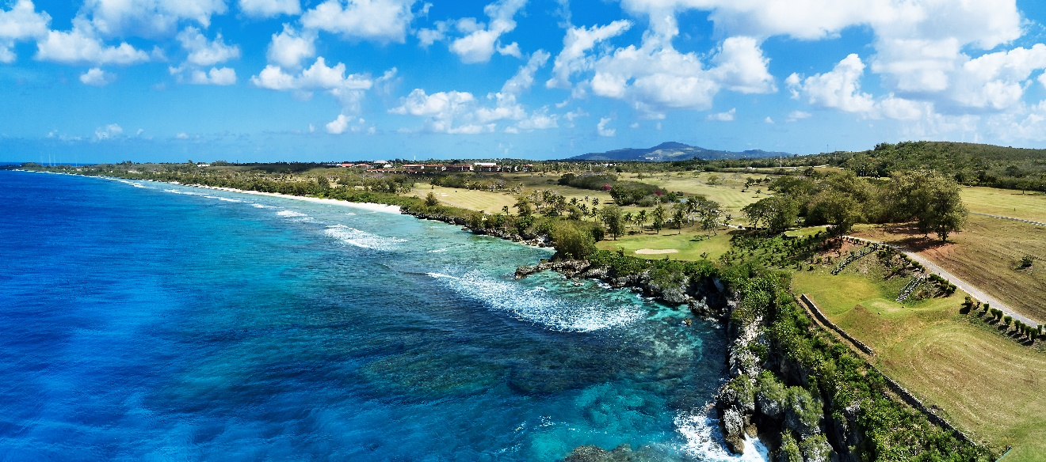
The 19th Annual HANMI Charity Classic Golf Tournament will be held on Aug. 14, 2021, at Coral Ocean Resort in Saipan.

###
For More Information:
Catherine Perry
670.288.8433

