

FOR IMMEDIATE RELEASE May 3, 2019

TRADERS INSURANCE GIVES $2.5K FOR HANMI GOLF TOURNEY

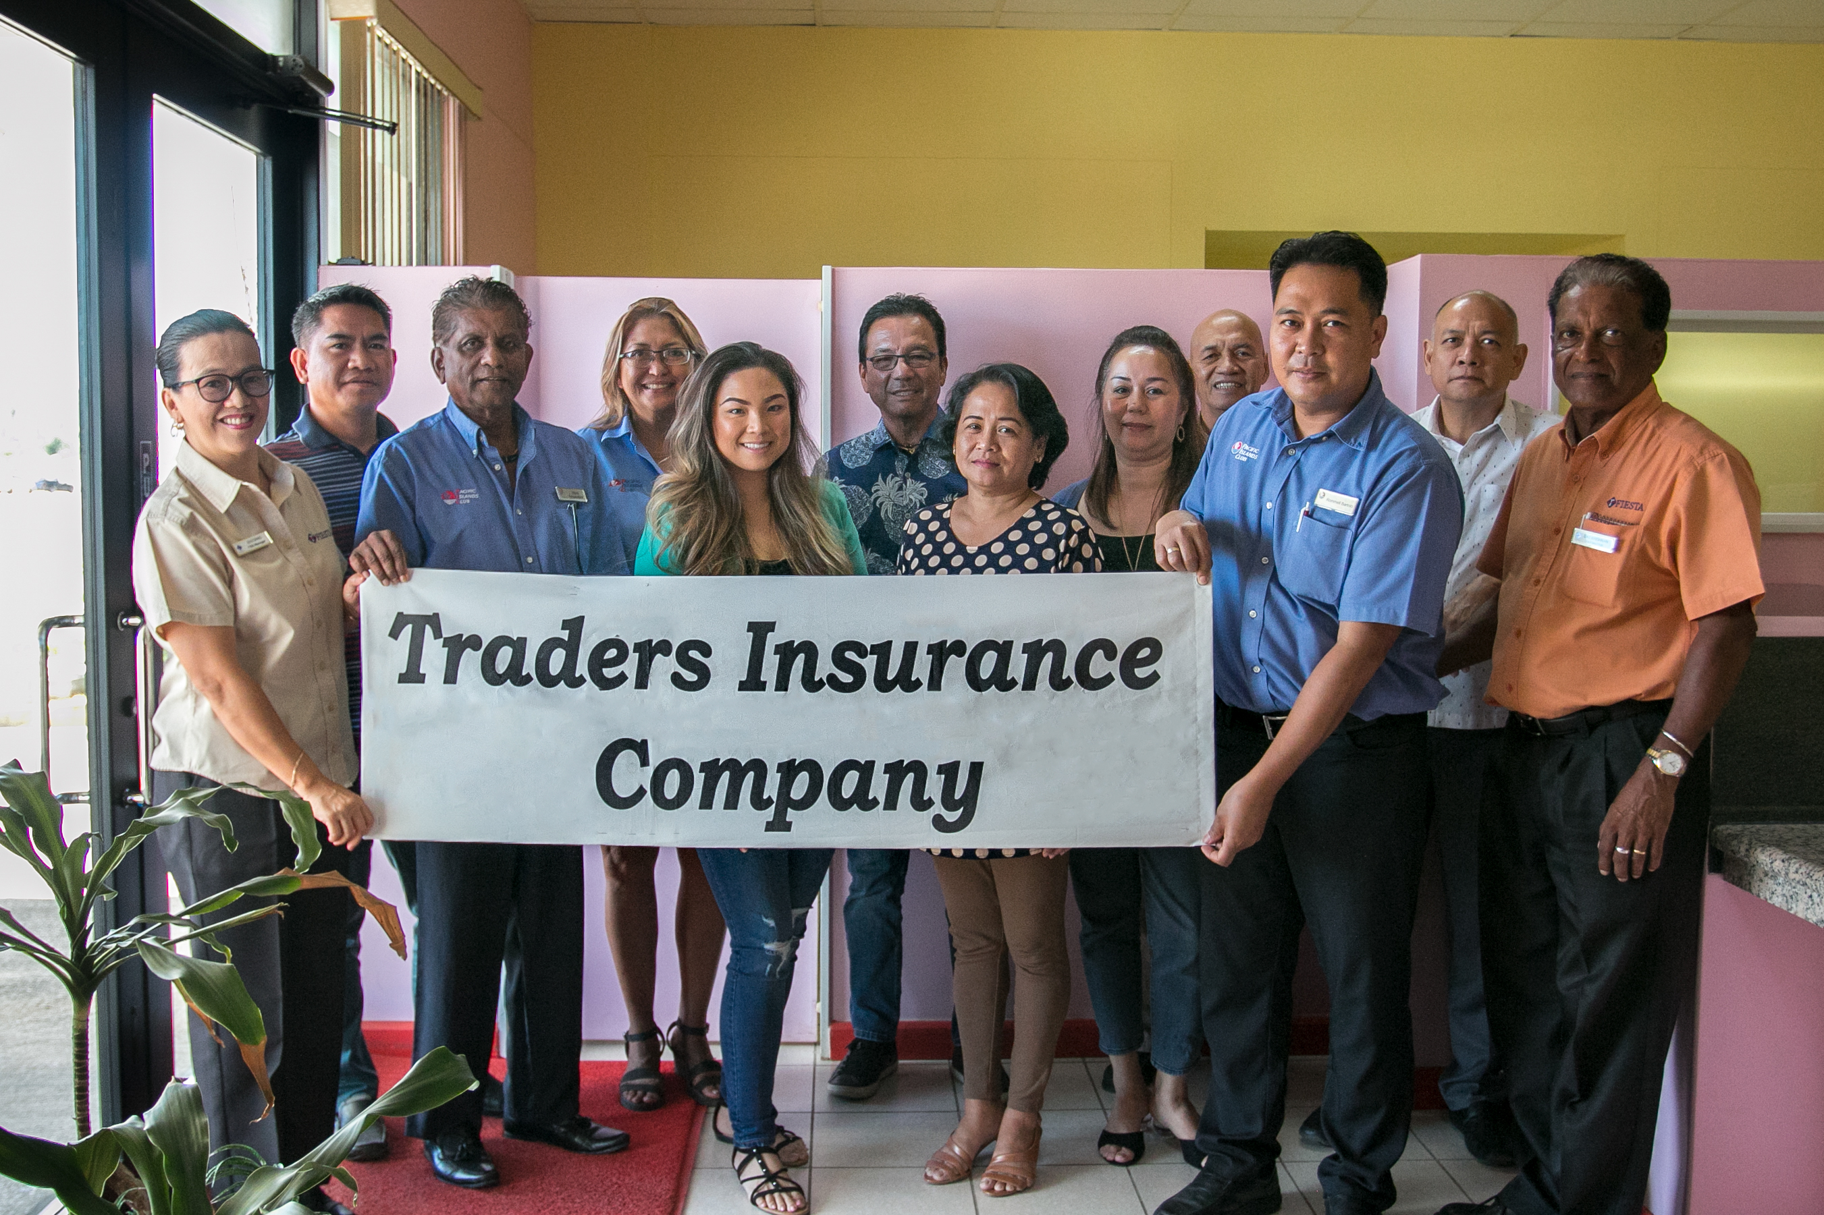

SAIPAN, NORTHERN MARIANA ISLANDS – At their office in Chalan Kanoa, Saipan, on Apr. 29, 2019, Traders Insurances donates a $2,500 hole-in-one prize for the 18th Annual HANMI Charity Classic Golf Tournament scheduled for May 11, 2019, at LaoLao Bay Golf Resort. From left, Tournament Committee Member Socorro Huliganga, Traders Insurance Underwriter Ferdinand S. Javillonar, Tournament Committee Chairman Steve Balakrishna, HANMI Chairwoman Gloria Cavanagh; Traders Insurance Underwriter Ma. Krizia D. Mendoza, President Pablo B. Mendoza, Accountant Chona O. Laguador, Insurance Underwriter Jenny G. Ariar, and Manager Ernest S. Licop; Tournament Committee Member Rommel Bartolo; Traders Insurance Secretary/Treasurer Fidel S. Fernandez, and Tournament Committee Member Das Krishnan.

###
For More Information:
Catherine Perry
670.288.8433

