FOR IMMEDIATE RELEASE May 9, 2019

PACIFIC SUBSEA DONATES TO HANMI GOLF TOURNAMENT

SAIPAN, NORTHERN MARIANA ISLANDS – With a donation of gift certificates for its unique submarine tour, Pacific Subsea Saipan has joined a long list of sponsors buoying up the 18th Annual HANMI Charity Classic Golf Tournament on Saturday (May 11), at LaoLao Bay Golf & Resort West Course.

“We began our partnership years ago with this tournament and always look forward to assisting,” said Pacific Subsea Saipan Operation Manager Scott Eck. “As Saipan’s only true submarine experience, we are hoping that whoever wins these gift certificates has an amazing time with us.”

A scratch golfer himself and former college player, Eck also “would like to wish everyone good luck this weekend.”

The tournament follows a black-jack double Peoria format and is offering more than $100,000 in cash, cars, hotel night stays and other prizes for players. Registration for the tournament has sold out.

“We thank Pacific Subsea Saipan for generously donating these incredible prizes for this weekend’s tournament,” said Tournament Chairman Steve Balakrishna. “In fact, the HANMI tournament has a great lineup of course and banquet prizes for adventures of land, sea, and yes, even sky. We’re looking forward to a great day on and off the course on Saturday.”

Hole-in-one prizes include $20,000 from Century Tours, a 2019 Mitsubishi Eclipse Cross from Triple J Motors, $20,00 from LT Travel, a 2019 Toyota Sienna from Atkins Kroll Saipan, $5,000 from Pacifica Insurance, a first-class roundtrip ticket from Saipan to Shanghai or Guangzhou on Sichuan Airlines from Saipan Travel Inc., and $2,500 from Traders Insurance.
For an additional $30.00, players may also compete for optional play prizes, including Accurate Drive on Line (#9), Accurate Drive Circle (#5), Aggressive Drive (#12), Longest Drive (#18), and Nearest to the Pin (#3, #7, #13, #17). The tournament will start at 7 a.m, and the awards banquet will be held the same day at 6 p.m. at Grandvrio Resort Saipan.

For more information, contact Tournament Chairman Steve Balakrishna at steve.balakrishna@picsaipan.com or 1.670.234.7976 or visit www.facebook.com/HANMI670.

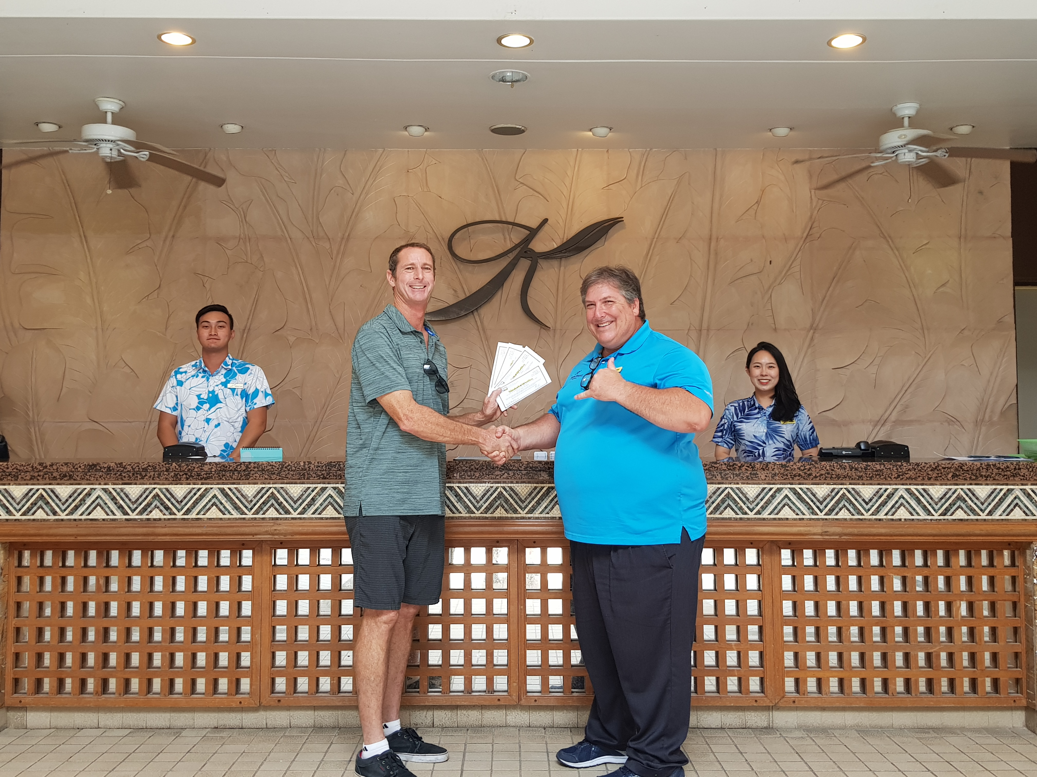
Pacific Subsea Saipan Operations Manager Scott Eck, left, donates submarine tour gift certificates on Apr. 12, 2019, at Kanoa Resort, Saipan, to Glenn Policare of the 18th Annual HANMI Charity Classic Golf Tournament Committee. The tournament will be held May 11, 2019, at LaoLao Bay Golf & Resort.
###
For More Information:
Catherine Perry
670.288.8433

