

FOR IMMEDIATE RELEASE Apr. 17, 2019

$20K FROM CENTURY TOURS AT HANMI TOURNAMENT

SAIPAN, NORTHERN MARIANA ISLANDS – Century Tours has joined the growing list of sponsors for the 18th Annual HANMI Charity Classic Golf Tournament, offering a $20,000 cash hole-in-one prize for the tournament on May 11, 2019, at LaoLao Bay Golf & Resort West Course.

The tournament is open to the first 144 paid registrants and follows a black-jack double Peoria format. Cash, cars, hotel night stays, and other prizes await the winners. The early bird tournament fee is $100 for those who register by next Friday (Apr. 26) at 5 p.m.

“We all know that our local tourism industry has taken a hit from Super Typhoon Yutu, but Century Tours has been just as generous with their sponsorship this year, as in years past,” said Tournament Chairman Steve Balakrishna. “We truly thank them for their support and commitment to HANMI and community organizations we support through their hole-in-one sponsorship.”

Additional hole-in-one prizes include a 2019 Mitsubishi Eclipse Cross from Triple J Motors, $20,000 from LT Travel, and $5,000 from Pacifica Insurance.
The fee increases to $120 after the early bird deadline. The fee includes green fee and the awards banquet. For an additional $30, players may also compete for optional play prizes, including Accurate Drive on Line (#9), Accurate Drive Circle (#5), Aggressive Drive (#12), Longest Drive (#18), and Nearest to the Pin (#3, #7, #13, #17). The tournament will start at 7 a.m, and the awards banquet will be held the same day at 6 p.m. at Grandvrio Resort Saipan. Registration forms are now available at: LaoLao Bay Golf & Resort, Pacific Islands Club Saipan, Fiesta Resort & Spa, Hyatt Regency Saipan, or www.facebook.com/HANMI670.

For more information, contact Tournament Chairman Steve Balakrishna at steve.balakrishna@picsaipan.com or 1.670.234.7976 or visit www.facebook.com/HANMI670.

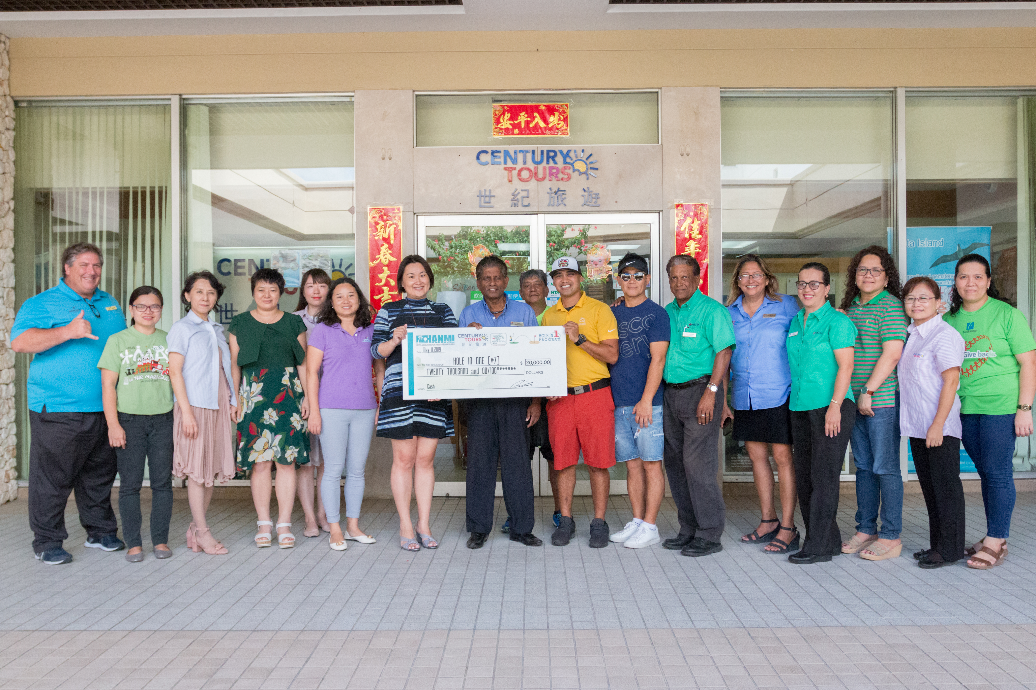
Century Tours presents $20,000 on Mar. 12, 2019, at their office in Susupe, Saipan, as a hole-in-one prize for the 18th Annual HANMI Charity Classic Golf Tournament to be held on May 11, 2019, at LaoLao Bay Golf & Resort. From left, tournament committee member Glenn Policare; staff and Operations Manager Rain Bao of Century Tours; tournament committee chairman Steve Balakrishna; committee members Franco Santos, Steve Jung, Das Krishnan; HANMI Chairwomen Gloria Cavanagh; committee member Socorro Huliganga; and staff of Century Tours.
s###
For More Information:
Catherine Perry
670.288.8433

